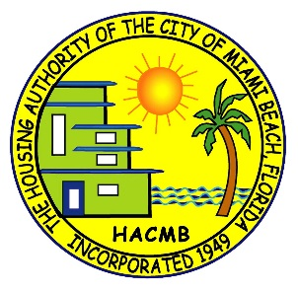

The Housing Authority of the City of Miami Beach

PUBLIC NOTICE

Notice is hereby given that two or more members of the Housing Authority Board of Commissioners may be in attendance and may participate in the German Minister of Housing, Urban Development, and Construction Delegation visit to Rebecca Towers on Thursday, May 9th, 2024, commencing at 1:30 p.m., at 150-200 Alton Road Miami Beach, FL 33139.

In compliance with the Americans with Disabilities Act (ADA), please contact (305) 532-6401, ext. 3020, in advance, if special accommodations are required.

